

School of Computer Science Engineering & Information Systems (SCORE)

WINTER SEMESTER 2025-2026

Name: M. Divyasri
Registration Number: 23MIS0174
Course Title: Agile Development Process and Devops Lab
Course Code: ISWE406P
Faculty: Dr. Sweta Bhattacharya
Slot: L3+L4

Assignment: Create an HTML file for your profile and complete the following:

1. Create a repository in GIT and create the following files:
- index.html
- Dockerfile
- Deployment.yaml

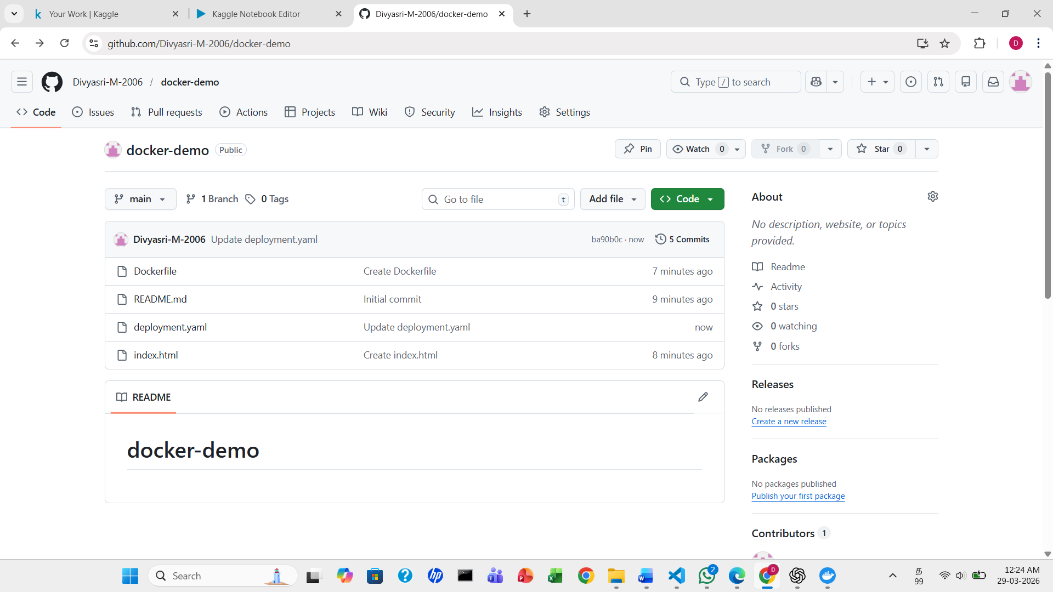

- Enable Kubernetes
  - Open the Docker Dashboard: Launch the Docker Desktop application on your system.
  - Navigate to Settings: Click the gear icon (Settings or Preferences) in the top-right or sidebar of the Docker Dashboard.
  - Select the Kubernetes Tab: In the Settings menu, find and select the Kubernetes tab.
  - Enable Kubernetes: Check the box labeled Enable Kubernetes.
  - Apply & Restart: Click the Apply & Restart button at the bottom of the settings window. Docker Desktop will then download the necessary Kubernetes components and start a single-node cluster. This may take a few minutes the first time

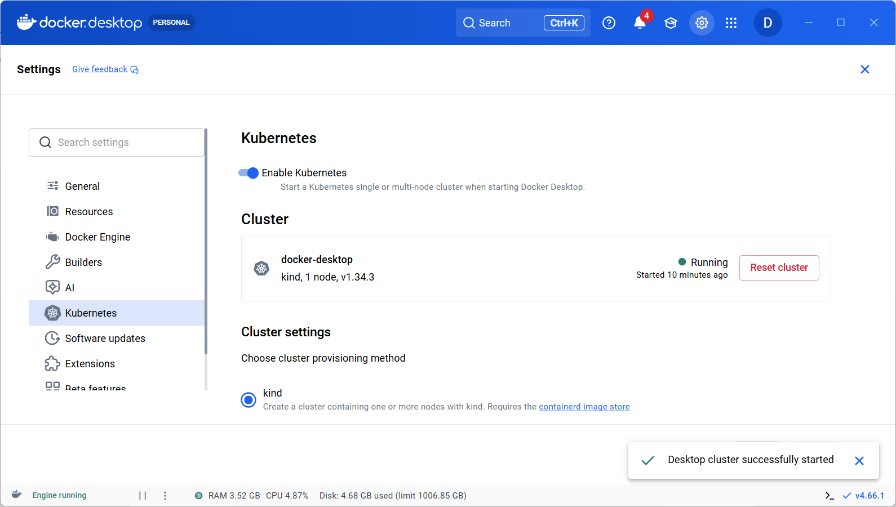

- Open Jenkins
In Jenkins Setting --> Credentials

New Credentials – User name: <should use the Docker Desktop username>, password <same as Docker Desktop password>, ID:<dockerhub>, Description <any>

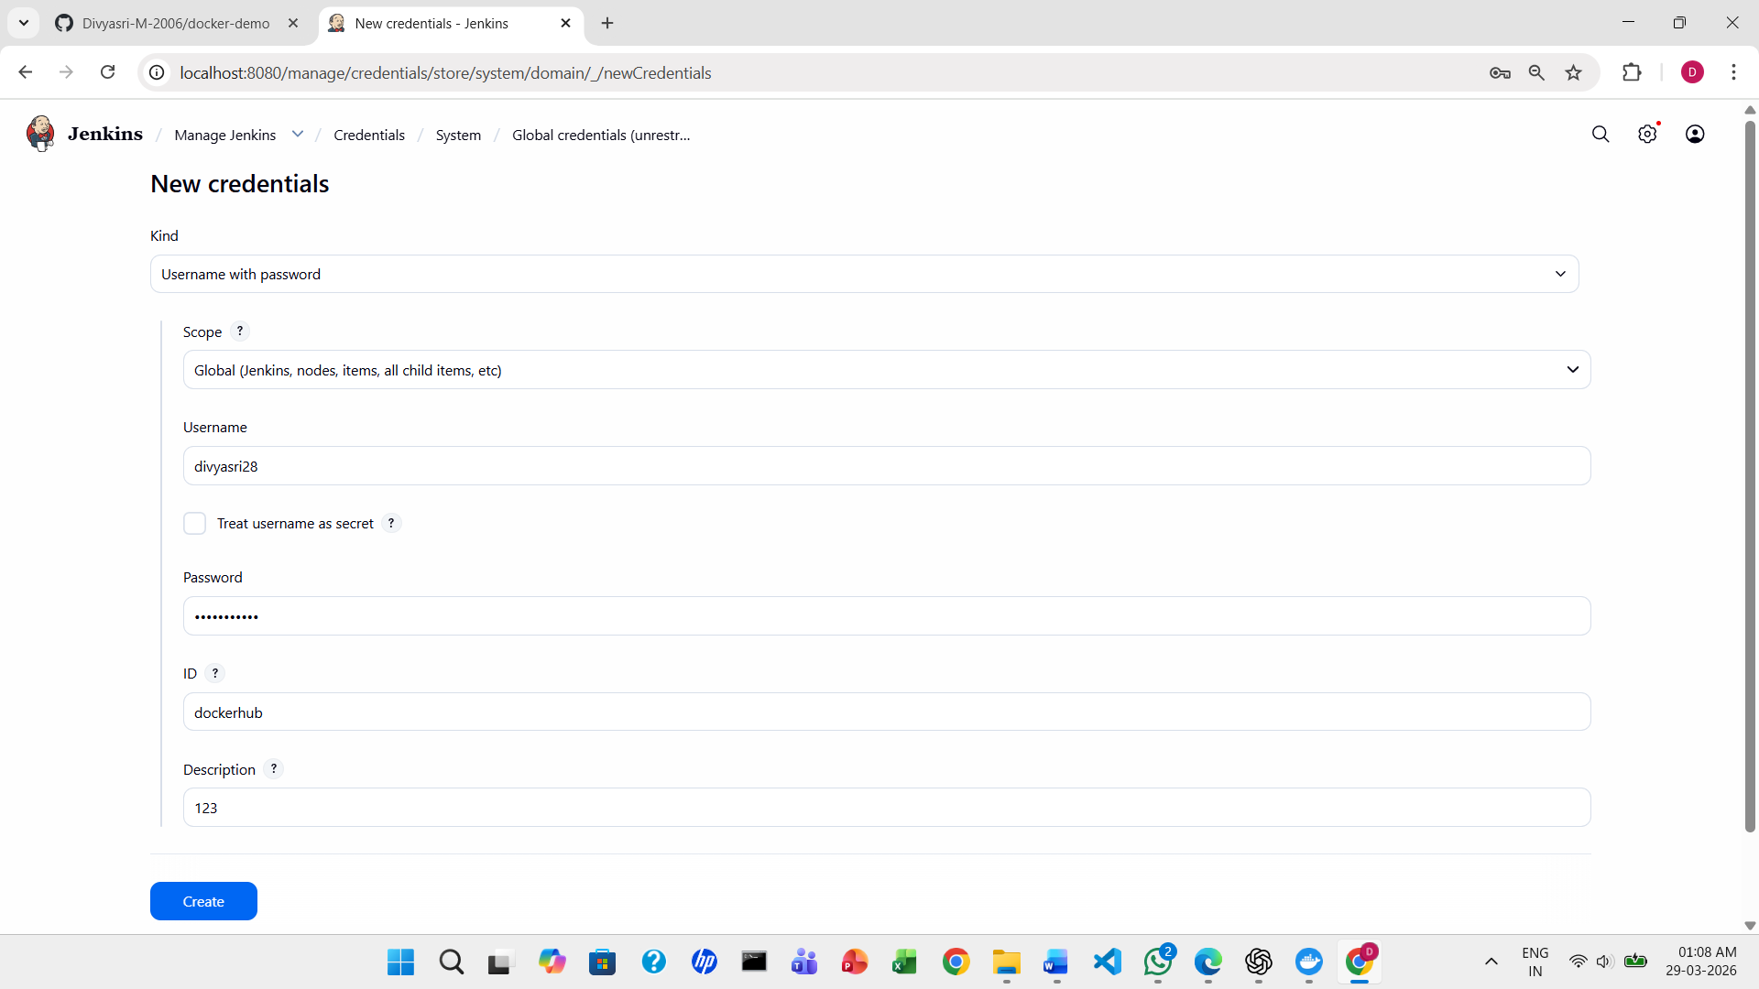

New Credentials – Secret – Browse C: User->Administrator-->.kube

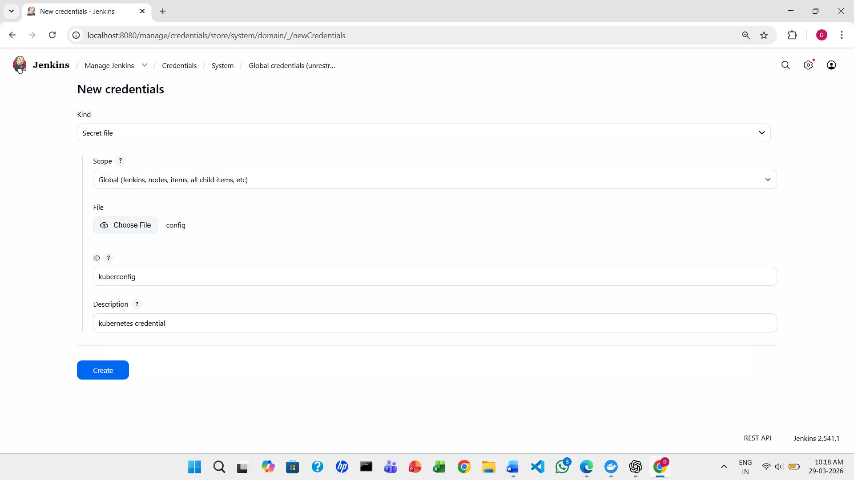

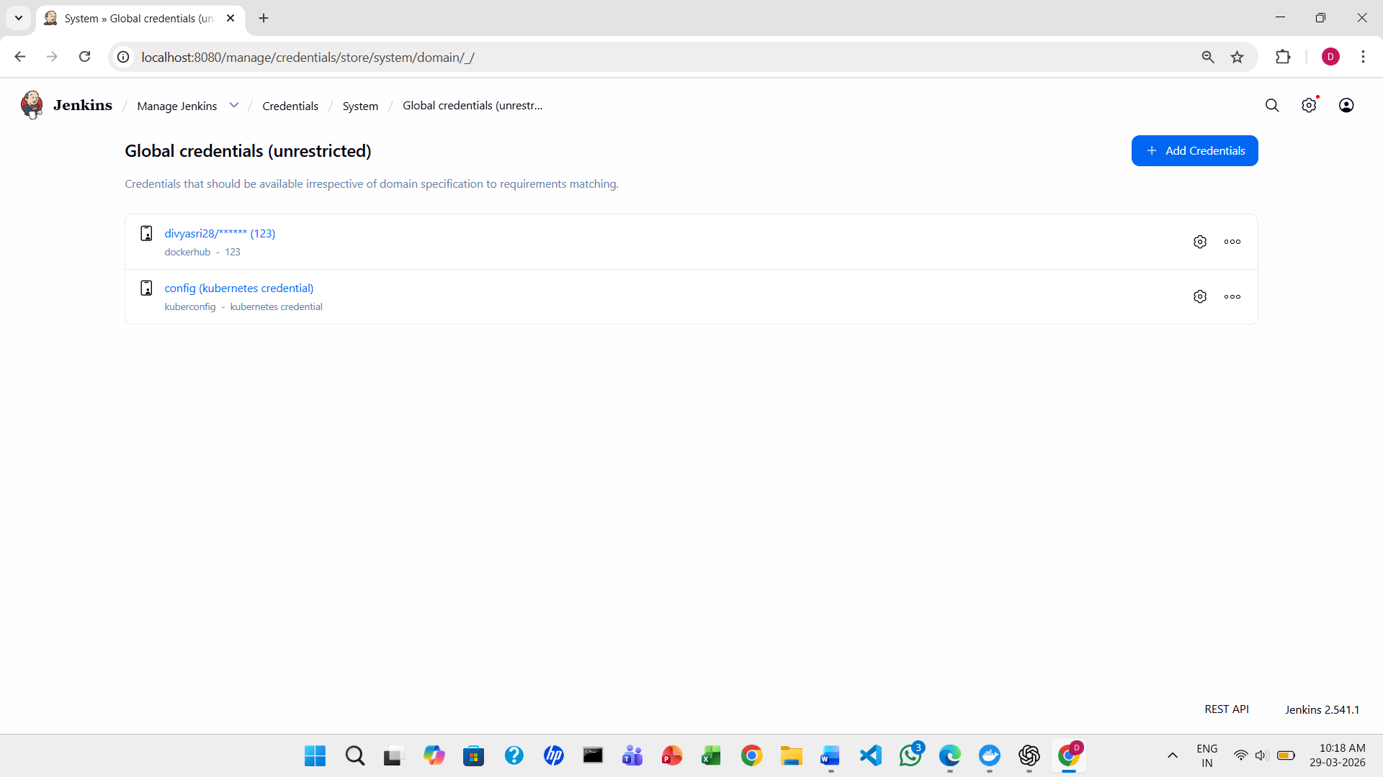

Create New Item -> Pipeline

Paste the code in pipeline script
  - Update URL of GIT repository
  - Make sure credentialsId: “dockerhub” same as mentioned in credentials
  - Make sure that the ID mentioned in credentials “kuberconfig” is same as in script - Run the Build Pipeline:

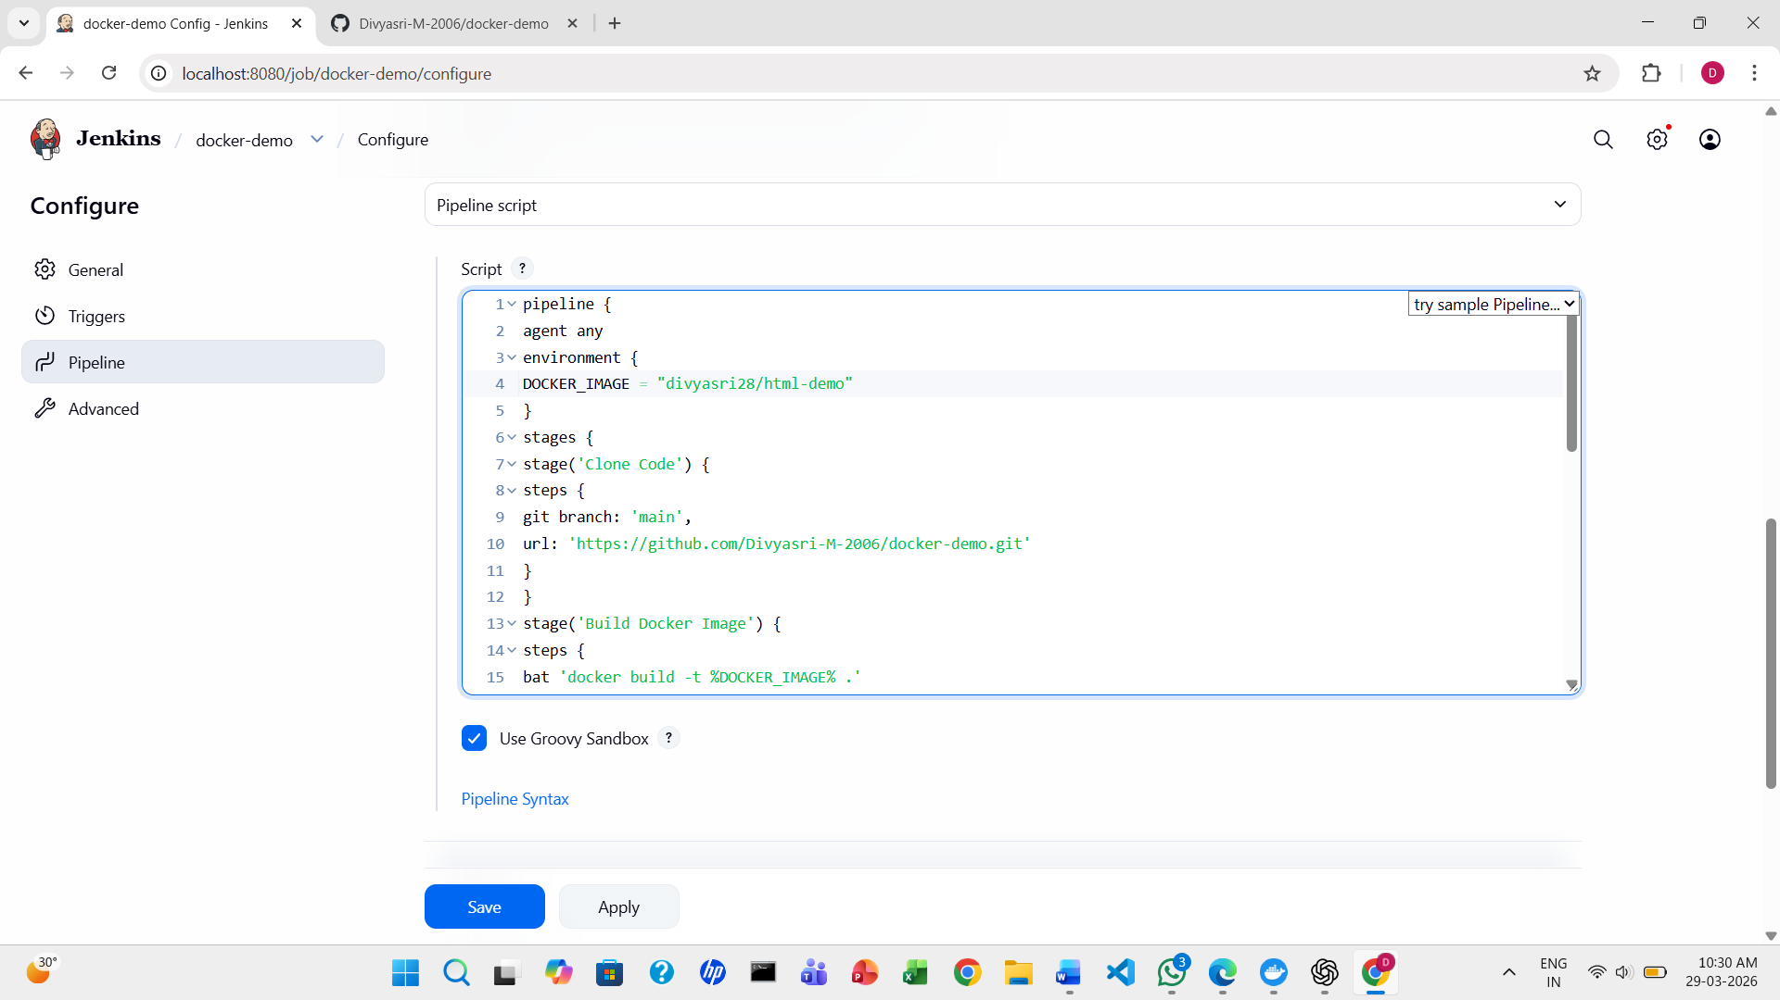

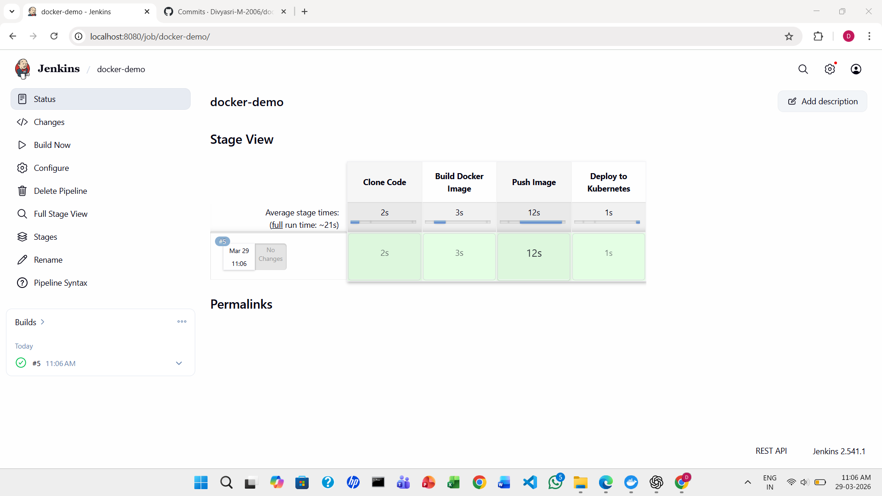

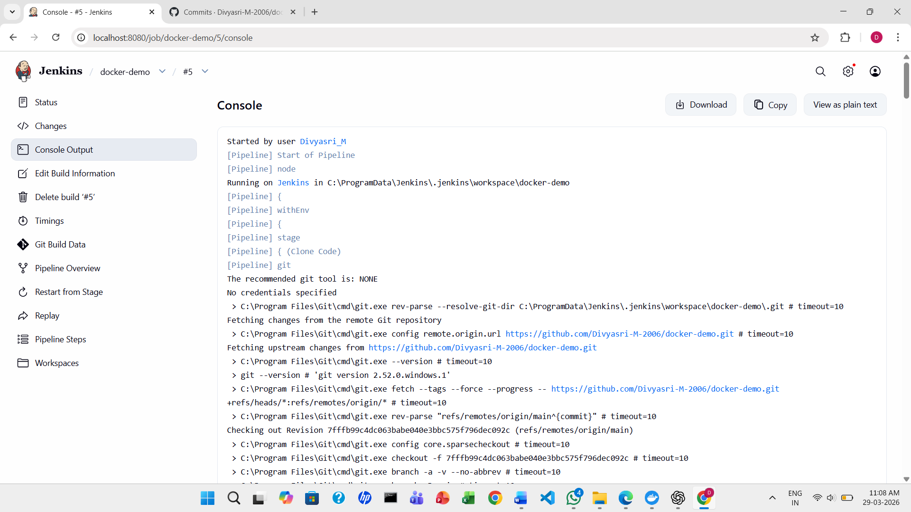

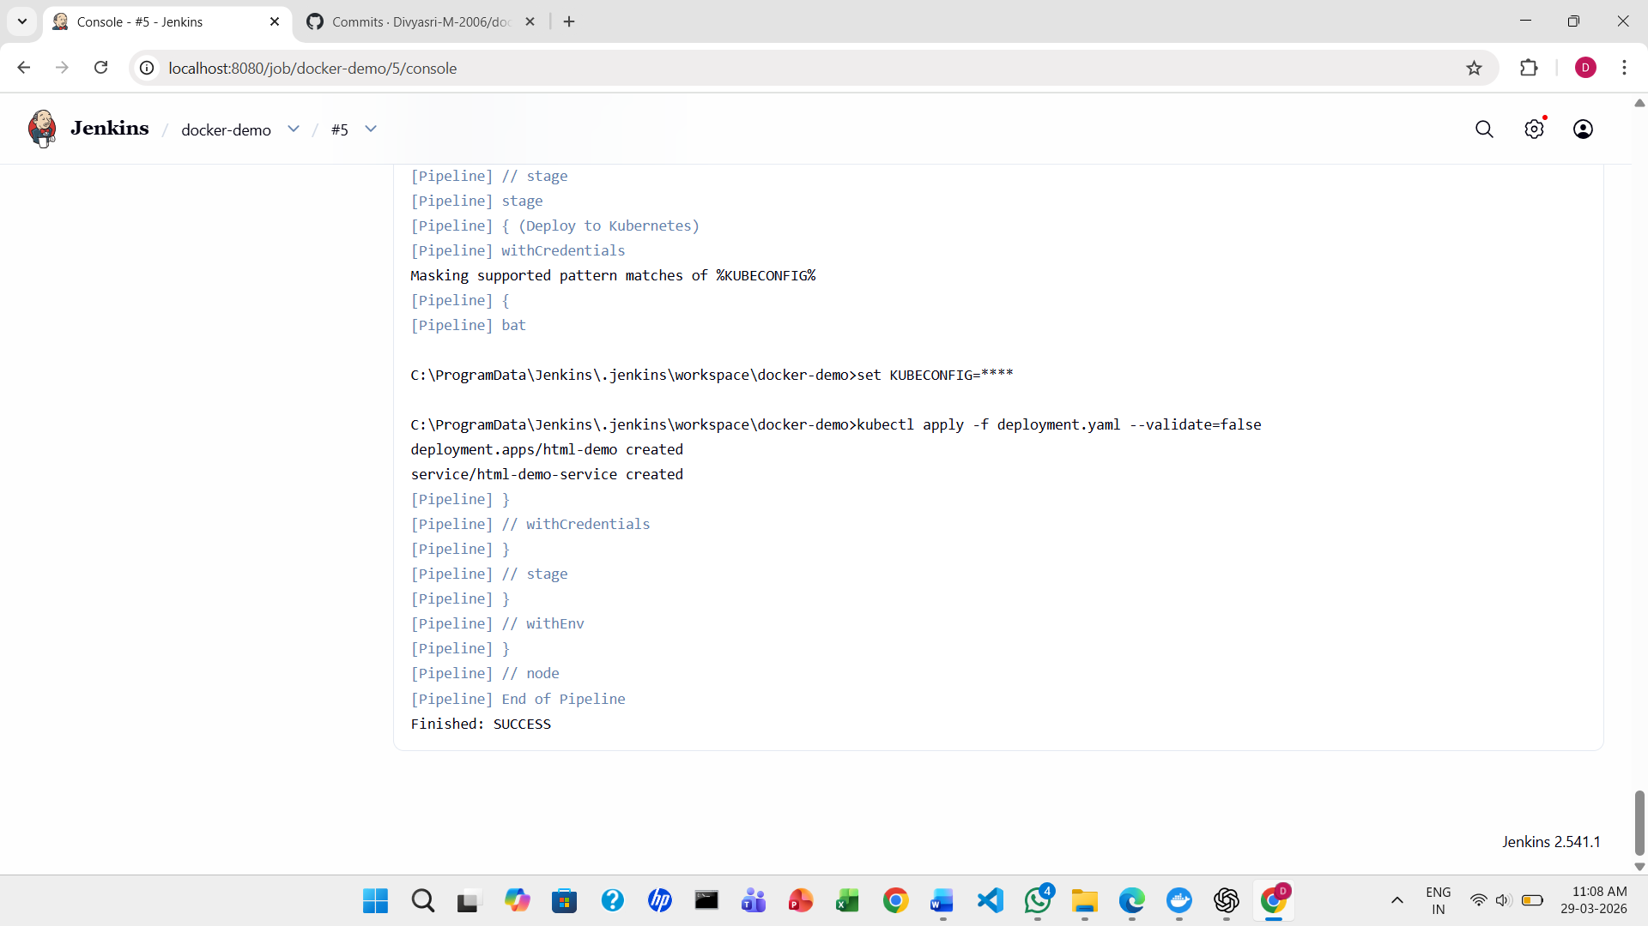

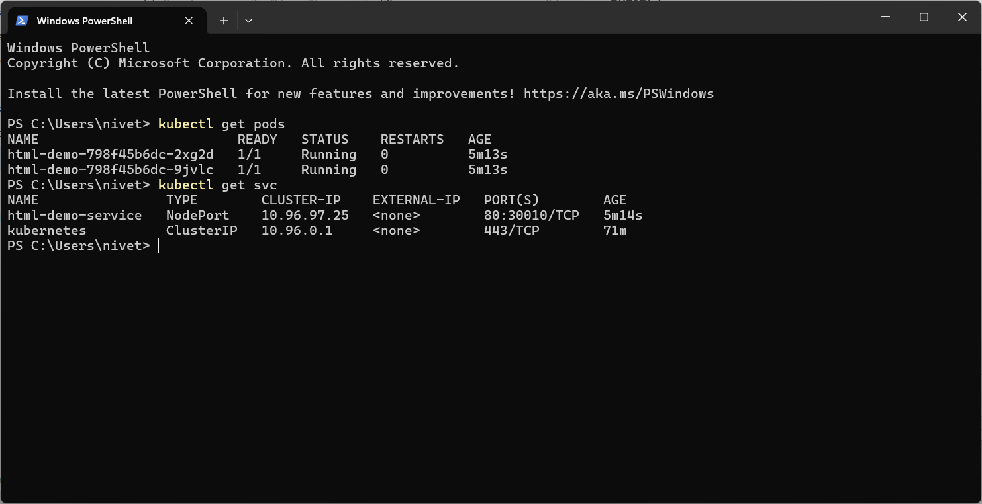

Dokerdesktop View

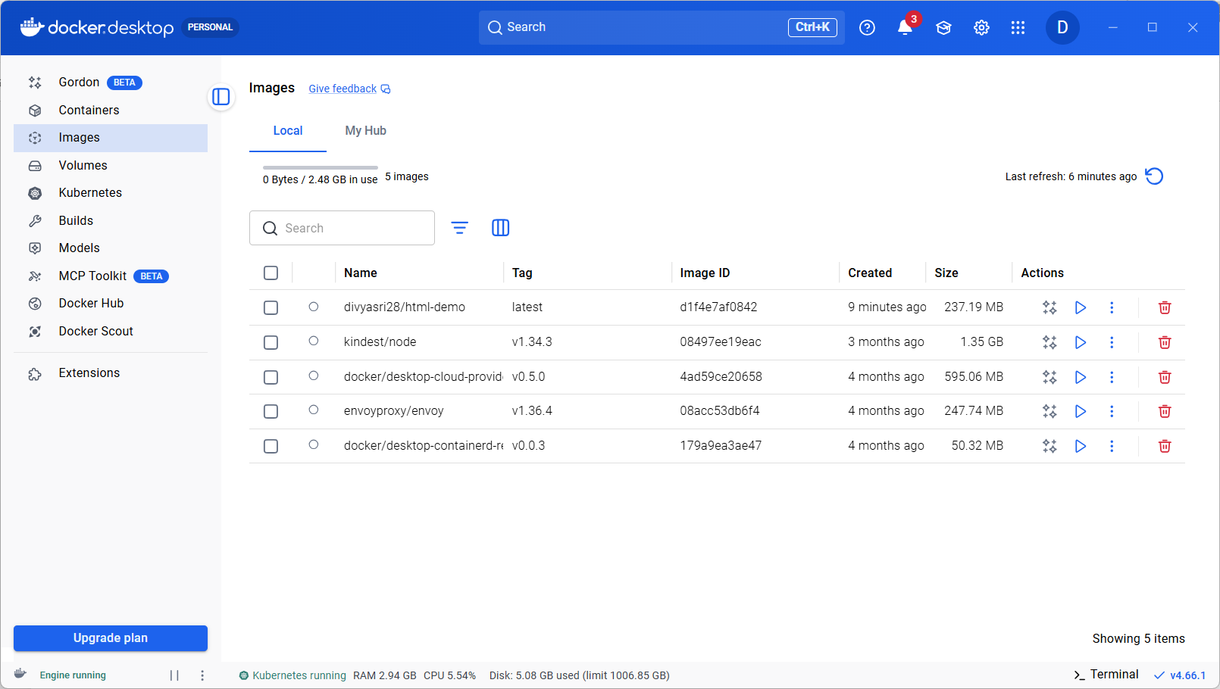

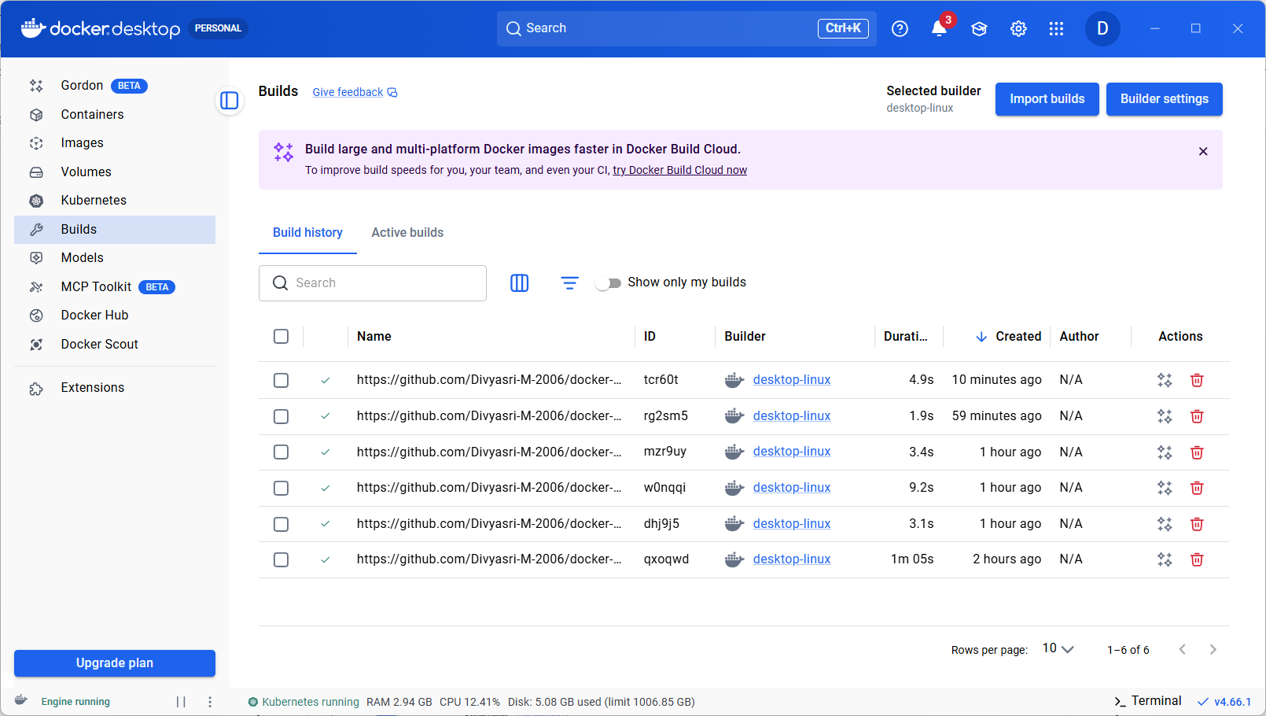

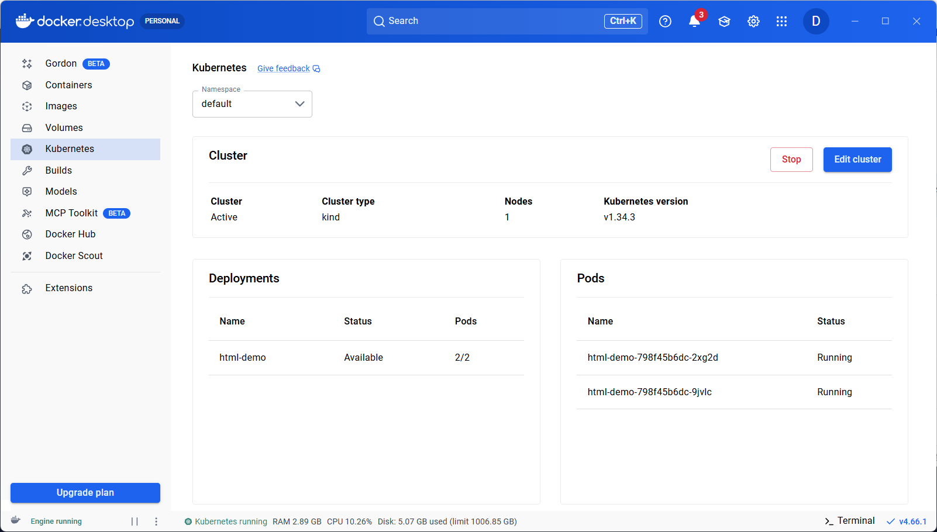

Also, the HTML page should open in the port mentioned in deployment.yaml file: nodePort: 30010
So check if the HTML file open in http://localhost:30010

